**Ideation Phase**

**Define the Problem Statements**

|  |  |
| --- | --- |
| Date | 28 June 2025 |
| Team ID | LTVIP2025TMID58256 |
| Project Name | Visualizing Housing Market Trends: An Analysis of Sale Prices and Features using Tableau |
| Maximum Marks | 2 Marks |

**Problem Statement:**

**Real estate analysts, marketing teams, and executives at ABC Company** struggle to make confident, data-driven decisions due to the complexity and volume of housing data.

Despite having access to raw housing records, they face challenges in identifying patterns, understanding the effect of renovations on sale prices, and evaluating how house features like age, bathrooms, bedrooms, and floors influence market value.

These stakeholders lack a **centralized, visual platform** that presents key insights at a glance resulting in missed trends, delayed decisions, and inefficient pricing strategies.

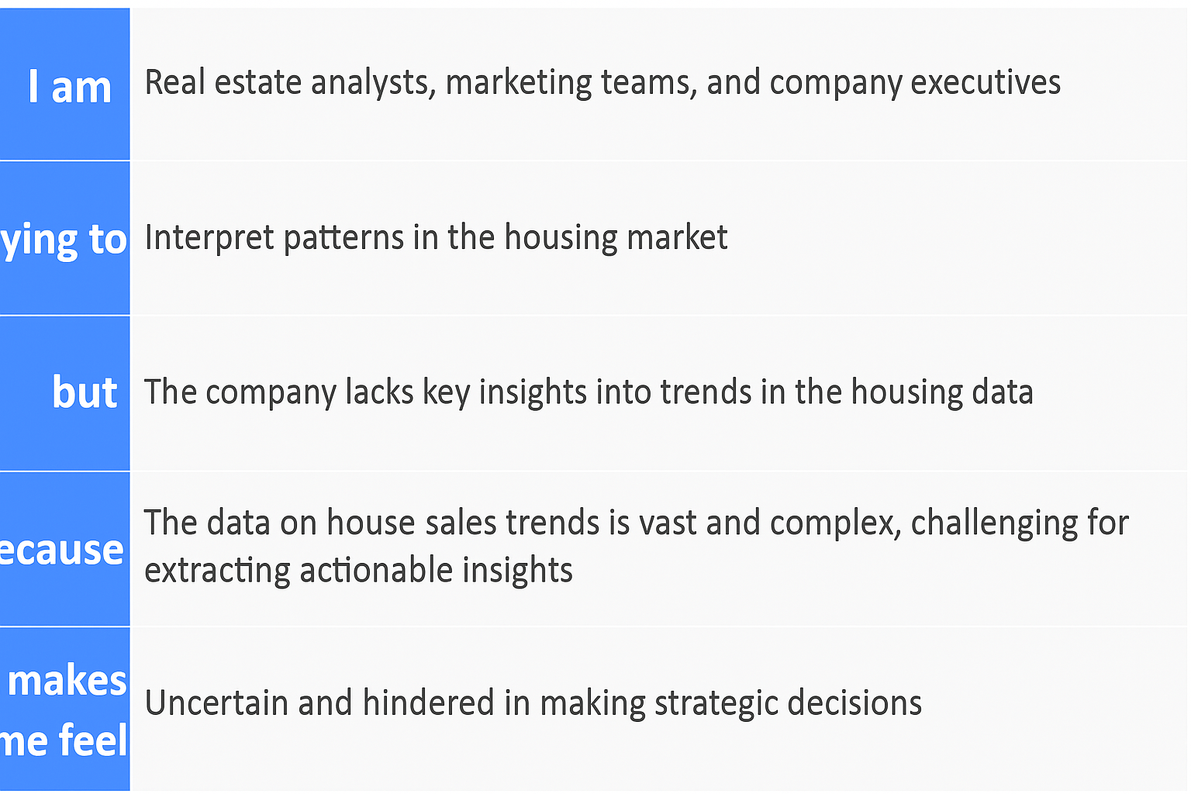

|  |  |  |  |  |  |  |  |  |  |  |  |  |  |  |  |  |  |  |  |
| --- | --- | --- | --- | --- | --- | --- | --- | --- | --- | --- | --- | --- | --- | --- | --- | --- | --- | --- | --- |
| |  |  |  |  |  |  |  |  |  |  |  |  |  |  |  |  |  |  |  | | --- | --- | --- | --- | --- | --- | --- | --- | --- | --- | --- | --- | --- | --- | --- | --- | --- | --- | --- | | |  |  |  |  |  |  | | --- | --- | --- | --- | --- | --- | | **Problem Statement (PS)** | **I am (Customer)** | **I’m trying to** | **But** | **Because** | **Which makes me feel** | | **PS-1**: Difficulty understanding housing price trends | Real estate analysts, marketing teams, and company executives | Interpret patterns in the housing market to make informed decisions | The company lacks key insights into trends in the housing data | The data is vast, complex, and not visualized effectively | Uncertain and hindered in making strategic decisions | | **PS-2**: Struggling to assess renovation impact on pricing | Real estate professionals and decision-makers | Understand how renovations influence sales and buyer preferences | Insights about renovation impact on house prices are unclear | The data is not broken down by renovation status and pricing trends | Frustrated and unsure about renovation ROI | | |